**NETWORKS LAB : 3**

**Basic Socket Programing (Working with A Single Threaded File Transfer Application)**

**Date: 25​ th​ January, 2018**

**15CS10031 Pankaj Dhurve**

**15CS30025 Sachin Kumar**

**Procedure:**

1. The file transfer client​ sends a file to the server (file size should be at least 1 MB)

2. The file transfer server receives the file, and returns back an acknowledgement (after the file transfer is complete) with the MD5 checksum of the file.

3. The protocol works as follows.

a. The client first Informs the file name and the file size to the server by sending a hello message.

b. The server acknowledges the hello message.

c. The client forwards file data over the stream/datagram socket to the server

d. The server receives the data, reconstruct the file at the server side, creates the MD5 checksum of the entire file e. The server acknowledges the client with the MD5 checksum of the file.

f. The client creates MD5 checksum of the original file before transfer, and matches it with the received MD5 checksum from the server. The client prints a message at the console “MD5 Matched” or “MD5 Not Matched”, and exists.

**TCP CLIENT:**

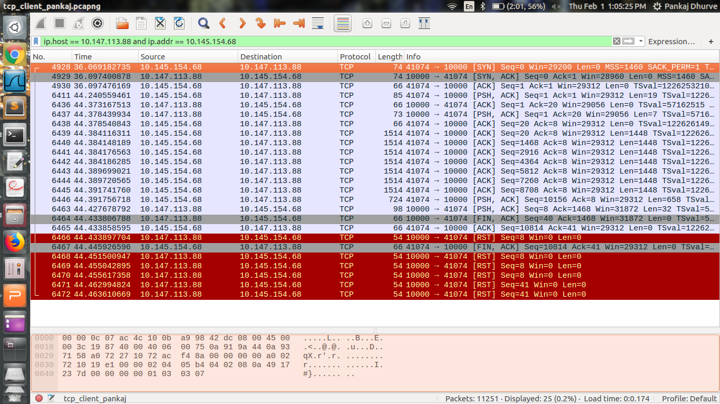

|  |  |
| --- | --- |
| Length | TCP Packets |
| 54 | 6 |
| 66 | 6 |
| 73 | 1 |
| 74 | 2 |
| 85 | 1 |
| 98 | 1 |
| 724 | 1 |
| 1514 | 7 |
|  | 25 |

Retransmissions = 0

Time to send : 463610669 - 069183725 = 394,426,944

**TCP SERVER:**

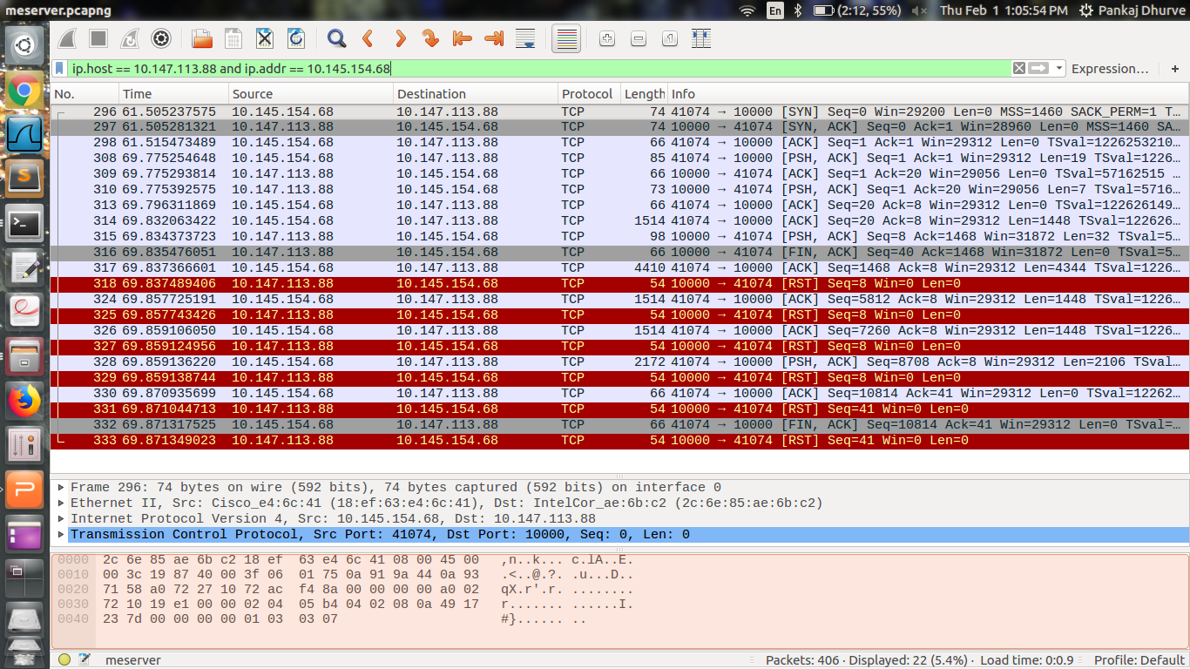

|  |  |
| --- | --- |
| LENGTH | TCP PACKETS |
| 54 | 6 |
| 66 | 6 |
| 73 | 1 |
| 74 | 2 |
| 85 | 1 |
| 98 | 1 |
| 1514 | 3 |
| 2172 | 1 |
| 4410 | 1 |

Total Packets 22

Retransmissions = 0

Time to receive : 871349023 - 505237575 = 366111448